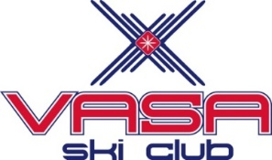 7th Annual 2023 Midwest Nordic Rendezvous
When: January 7-8, 2023
Where: Hickory Meadows, Traverse City, MI
Guest Instructor: Lindsey Dehlin

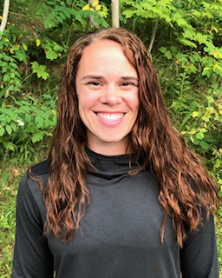
Vasa Ski Club is hosting two time Olympian Nordic Skier, Lindsey Dehlin from Marquette, Mi as our guest instructor. She will be sharing the latest drills and hone in on your xc skiing skills to help start your Nordic season off right! Hurry and sign up, limited space! Nordic clinics available for all abilities and disciplines. Come and ski with an Olympian! Share the passion Lindsey has for Nordic skiing and winter.
Join us for our 7th annual Midwest Nordic Rendezvous with our guest xc ski instructor Lindsey Dehlin, two-time Olympian from Marquette, Mi! Dehlin was a two-sport athlete at Northern Michigan, competing in cross country and Nordic skiing from 2002-07. She was an NCAA National Champion, a five-time NCAA All-American and a two-time member of the U.S. Olympic team in Nordic skiing. Dehlin is a native of Mahtomedi, Minn., and graduated from NMU in 2011 with a degree in liberal arts. She and her husband, Daniel Dehlin, reside in Marquette with their elven year-old sons, Ethan and Chase.
Register at www.vasaskiclub.org

Saturday January 7, 2023
- 8:30am-9:45am Beginner classic
- 10:00am-11:15am Intermediate Classic
- 12:15pm – 1:30pm Beginner skate
- 1:45pm – 3:00pm Intermediate Skate

Sunday January 8, 2023
- 9am - 10:15am Advanced Classic
- 10:30am – 11:45am Advanced Skate

Please check out www.vasaskiclub.org for more clinics being held to improve your individual xc skiing skills.

Name: Phone:

E-mail: TOTAL FEES:

Register on line at VasaSkiClub.org or complete a separate registration form for each individual and mail form(s) and check payable to Vasa Ski Club and mail to 2984 Cedarwood Lane, TC Mi 49686 Please check e-mail frequently for possible schedule changes and current ski conditions.
This event is open for PSIA continuing education credit taken as a Workshop or can go for a Level 1 or 2 Certification; must register through PSIA-C
For further information email: amy68fly@yahoo.com

