# Midwest Nordic Rendezvous

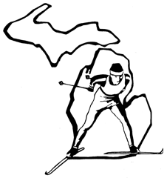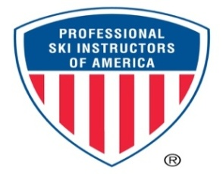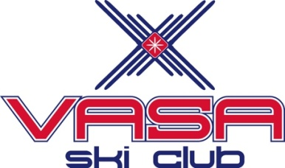

**Michigan Cup**

|  |  |
| --- | --- |
| **When:** January 6 & 7, 2018 | **Where:** Timber Ridge Resort  Traverse City, MI 49686 |
| **Guest Instructor:** Emily Lovett |

**Join us for the second annual Midwest Nordic Rendezvous with our guest instructor Emily Lovett** from Steamboat Springs, Colorado! Her roots come from Michigan where some of her best childhood memories are on cross country ski outings with her family.  She attended Kalamazoo College & eventually moved to Steamboat in 1995. She soon found her passion & joined the PSIA Rocky Mountain Division & USSA in 1996.  Emily coached the Steamboat Springs high school cross-country ski team for 8 years. She currently hosts and coaches instructor groups, master’s groups, women’s fitness groups, and co-organizes and instructs at the West Yellowstone Ski Festival Camp and the Steamboat Springs Nordic Camp. She recently became the Nordic Specialist for the PSIA National Team. Join us for our weekend clinics and social get-together!

**Schedule of Clinics & Events**

**Youth & Adult Programs – Saturday, January 6**

* **8:30 - 10:30am, All Area High School Skiers - Free**
* **11:00am – 12:00pm, Middle School Skiers - Free**
* **12:00 – 1:00pm, Adult Beginners** - **Free to VSC members, non-members $25** (includes trail pass but not equipment rental)

**Skier Social and Presentation – Saturday, January 6**

* **5:30 – 7:30pm, light meal and drinks provided. BYOB. Includes Emily Lovett Q & A**

**Technique Clinics – Sunday, January 7**

**Fees:** Adult $25/clinic or two clinics for $40 (includes trail pass but not equipment rental)

* **8:30 - 10:00am, Intermediate Classic**
* **10:30am – 12:00pm, Intermediate Skate**
* **1:00 - 2:45pm, Advanced Classic**
* **3:15 – 5:00pm, Advanced Skate**

**Name: Phone:**

**MI Cup Team (if applicable): Age:**

**E-mail: TOTAL FEES:**

Check the box for clinic choice(s). Early Registration is recommended.

Make checks payable to Vasa Ski Club & mail to Ella, c/o Timber Ridge, 4050 Hammond Rd., TC 49686

Please check e-mail frequently for possible schedule changes and current ski conditions.

This event is open for PSIA continuing education credit taken as a Workshop; must register through PSIA-C

For further information email: [**amy68fly@yahoo.com**](mailto:amy68fly@yahoo.com)